SPH3U0 Questions to Get You Started on your Exam Review….
Kinematics
1. A car travelling at an initial velocity of 60.0 km/h east accelerates at 0.250 m/s² west for 20.0 seconds.
a) Find its final velocity.
b) How far did the car travel while it accelerated? ANS: a) 42.0 km/h b) 283 m

2. A student walks 45 m [West], then 75 m [North] and finally 22 m [East] to reach the school gym.
The entire walk lasted 3.6 minutes. Find:
a) The student's resultant displacement.
b) The student's average velocity.
c) The student's average speed. ANS: a) 78 m [17°W of N], b) 0.36 m/s [17°W of N] c) 0.66 m/s

3. A bartender slides a cold pop down the bar counter towards a customer who just misses catching the can.
The can slides off the counter with an initial velocity of 4.5 m/s horizontally. If the counter is 1.2 m high find:
a) the time it takes the can to land on the floor
b) the horizontal distance the can travels before landing on the floor
c) the final velocity of the can as it strikes the floor.
ANS: a) 0.49s, b) 2.2 m c) 6.6 m/s [47° below the horizontal]
Dynamics
3. State Newton's Three Laws of Motion.

4. A sled (mass 15.8 kg) is being pulled along horizontal ground with an applied force of 47.0 N [east]. There is a
frictional force of 17.8 N [West] opposing the motion. Find the sled's acceleration. Ans: 1.8 m/s² [East]

5. A crate with mass 50.0 kg is pushed with an applied force of 175 N at a constant velocity of
2.5 m/s on a rough floor.
a) Draw a free body diagram of the crate.
b) Find the coefficient of kinetic friction.
c) How would the coefficient of static friction compare with your answer to (b)? ANS: b) 0.357

6. An astronaut in her space suit has a weight of 1.225 x 10 ³ N on Earth. Her weight on the Mars is 4.50 x 10 ² N.
Find the acceleration due to gravity on Mars. ANS: 3.60 N/kg
7. Find the magnitude of the force of gravitational attraction between a 55.0 kg student and a 75.0 kg student who
are sitting 2.25 m apart. ANS: 5.43 x 10⁻⁸ N

Energy
8. A ball with mass 500.0 g is thrown up with an initial speed of 7.00 m/s from a cliff top 10.0 m above a river below.
Assuming air resistance can be ignored,
a) find the ball's initial gravitational potential energy, its initial kinetic energy and its initial total mechanical energy.
b) find the maximum height of the ball above the river.
c) find the final speed of the ball just before it lands in the river.
ANS: a) 49 J, 12 J, 61 J b) 12 m c) 16 m/s

Sound and Waves

11. a) What is the frequency of a sound wave that travels at 1.500 x 10 ³ m/s in water with a wavelength of 145 cm?
b) What is the wavelength of the wave when it is transmitted into air at temperature of 15.0 ° C?
c) The wave enters a large open-ended pipe and causes it resonate in its first resonant mode.
What is the length of the pipe? (Sketch the wave pattern).
ANS: a) 1.03 x 10 ³ Hz b) 0.329 m c) 16.5 cm

Electricity and Magnetism

12.A toaster (resistance 18.0), a blender (resistance 48.0 Ω) and a coffee maker (resistance 16.0 Ω ) are connected in
parallel with a 120 V wall outlet.
- Draw a diagram illustrating the circuit.
- Calculate the equivalent resistance of the three appliances and find the total current in the circuit.
- Calculate the current and power electrical power dissipated by each appliance.
ANS: a) 7.20 Ω b) 17 A c) Toaster-6.7 A, 8.0 x 10 ² W Blender-2.5 A, 3.0 x 10 ² W ,
Coffee Maker-7.5 A, 9.0 x 10 ²W

13. a) Discuss the basic principle of electromagnetism discovered by Oersted.

b) Draw the magnetic field associated with each conductor below, assuming positive conventional current is flowing in the direction indicated.

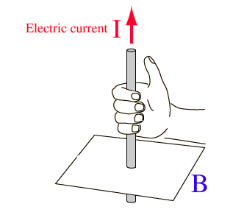
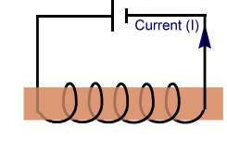
i) ii)

14. a) What is Faraday’s Law of Electromagnetic Induction?
b) Indicate the direction of the induced current and the associated magnetic field generated in the coils shown
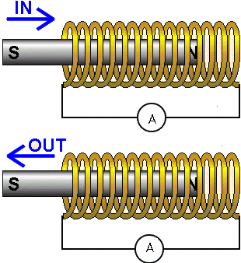
below:

